  - Objectives
Experiment (6)

Telnet


To achieve Telnet protocol and understanding mechanism of it’s work

  - Equipment / Program Requirements:
Ensp
Cisco Packet Tracker

  - Experiment Setup:
First make topology as shown under
Second devide it to 3 areas different and achieve ospf protocol and make configuration of ips in each router
Third enable telnet protocol with username and password
  - Simulation Results:

Topology:

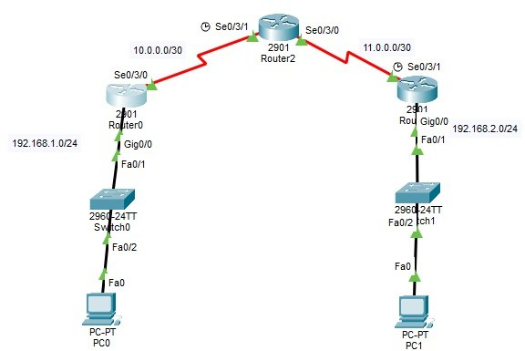

Router0 Configuration:

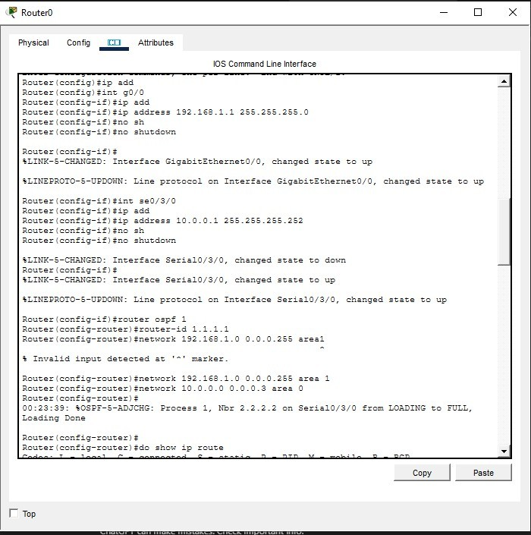

Router0 Ospf database:

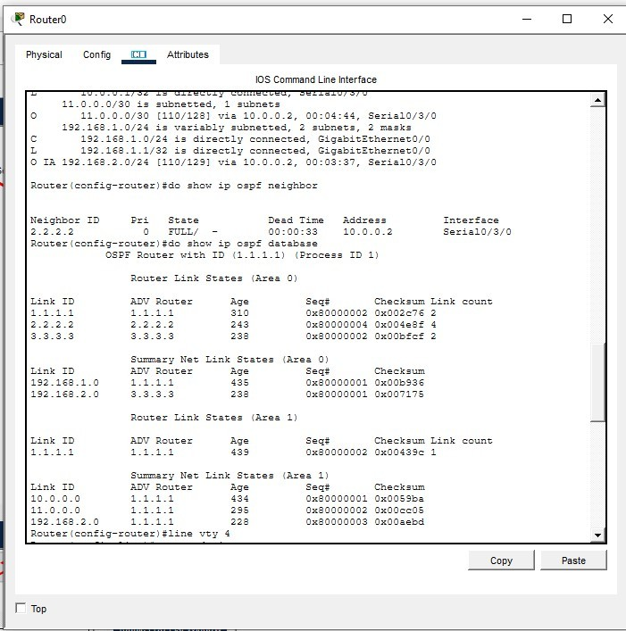

Router0 routing table:

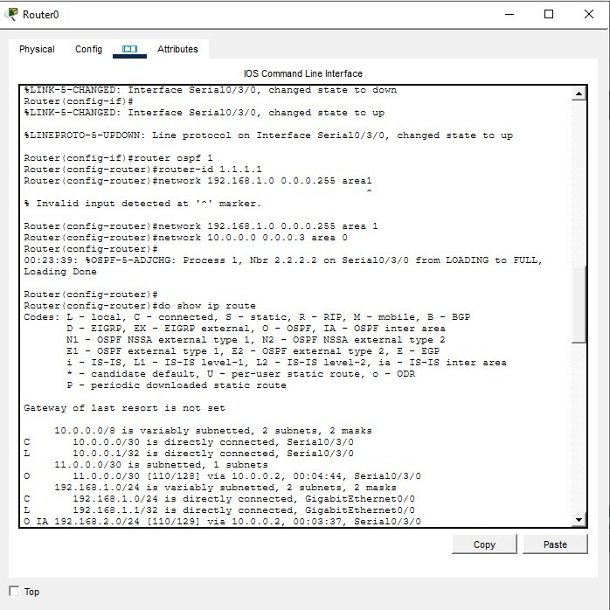

Router1 configuration:

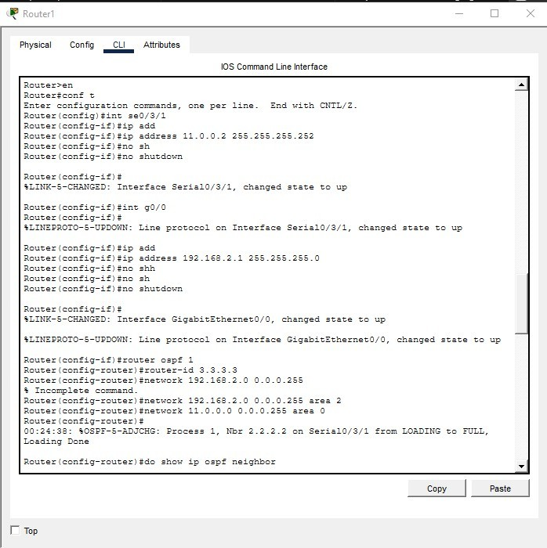

Router1 routing table:

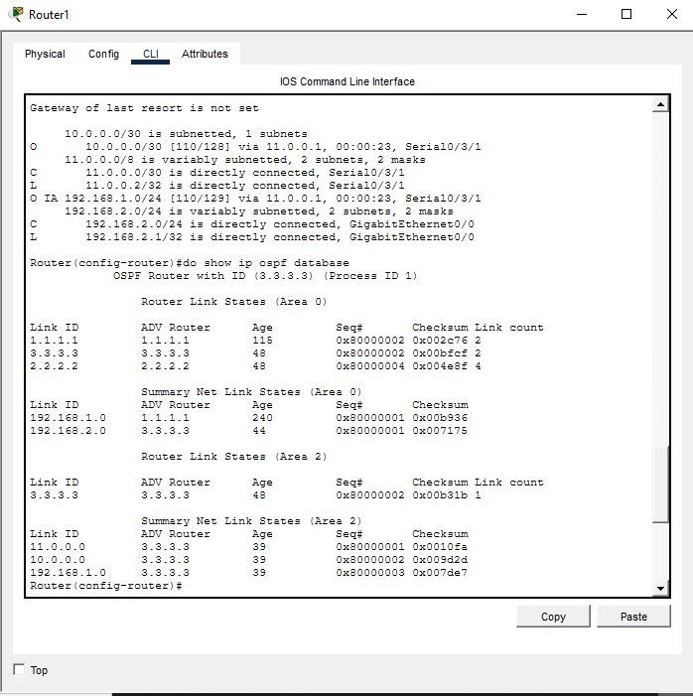

Router2 configuration:

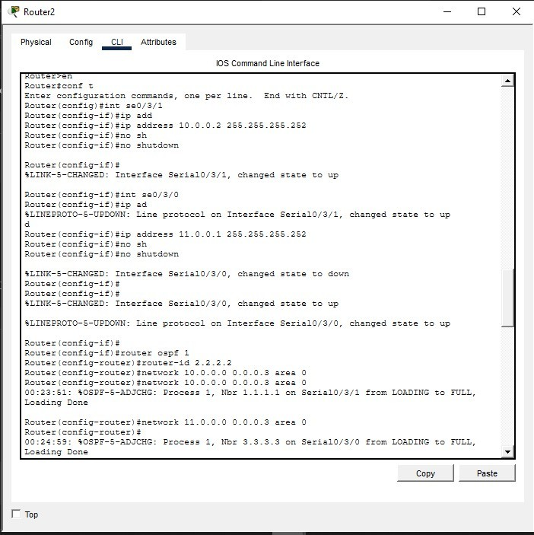

Router2 ospf database:

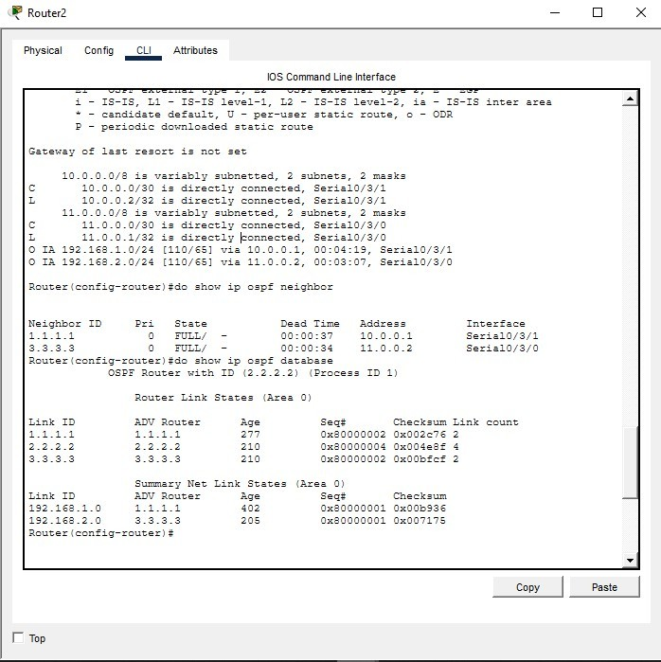

Router2 routing table:

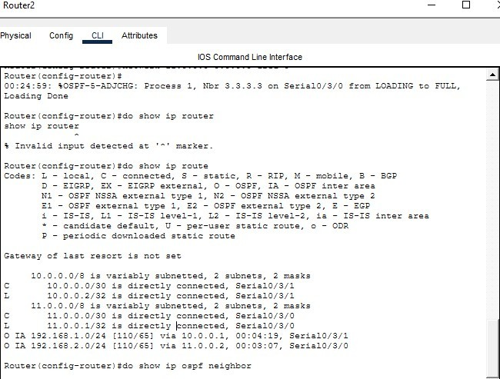

Telnet & Testing with Ping Protocol:

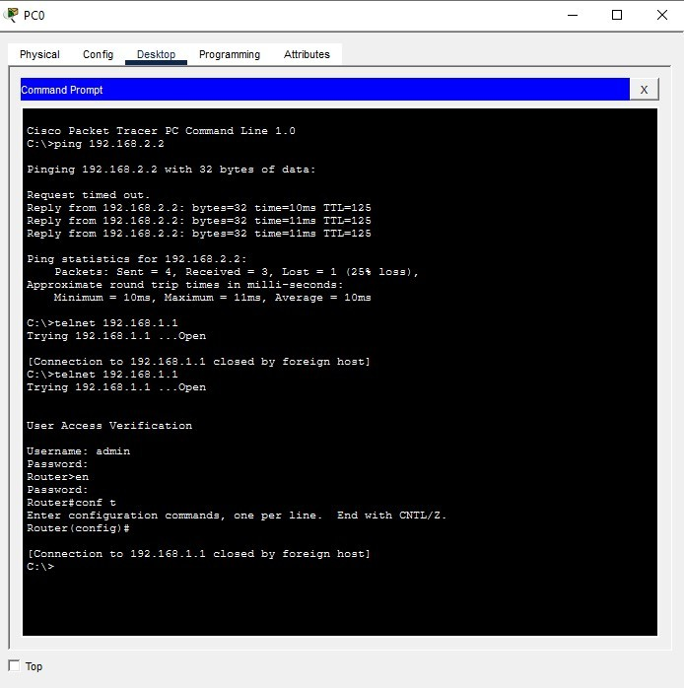

  - Conclusions:
It’s Important to use Telnet Protocol to make remote access to other devices

